Walter Denny on New Ways of Looking at Islamic Art
12 DEC 08:00 - 18:00
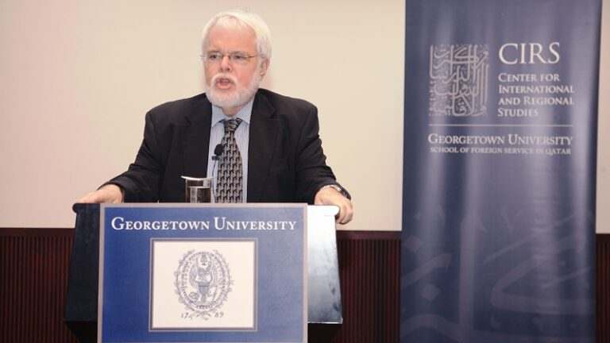
Walter B. Denny, Professor of Art History at the University of Massachusetts Amherst, gave a CIRS Monthly Dialogue lecture on “Innovation in the Visual Arts of Islam: New Ways of Looking at Islamic Art” on December 12, 2011. The lecture was a follow-up to a previous one Denny gave for CIRS at the “Innovation in Islam” conference that took place back in 2008. Subsequently, Denny contributed to the CIRS edited volume on Innovation in Islam: Traditions and Contributions, which was edited by Mehran Kamrava and published in 2011 by the University of California Press.
Contextualizing the concept of “innovation,” Denny described the ways in which it is understood in relation to art. He argued that innovation does not relate solely to the contemporary, but is, paradoxically, a historical feature of creative endeavors in all artistic categories. “One of the things that has always fascinated me about the history of Islamic art is the way that the past is constantly used as an inspiration for the present, and of course for the future,” he said. As an example, Denny said that the Mamluk style has been continually revived in the history of Egyptian architecture, as has the Ottoman style been reproduced in Turkey and elsewhere in the former Ottoman Empire. Innovation in art history is always based on something that came before, and “there is no such thing as total innovation. Innovation is always, to one extent or another, incremental,” he explained.
In much of the Islamic art that Denny examined, patterns and forms are not newly designed, but are borrowings from previous times, locales, and traditions that were either forcibly learned or subtly transferred as cultures came into contact with one another across the centuries. The geometric designs that have come to define art-works of the Islamic world are in fact derived from previous Roman traditions, Denny argued. This is not to say, however, that these works should not be considered innovative. Each iteration of a previous form is creating something new, and yet, it is something that must acknowledge its debt to a past formulation. Denny gave an example of how themes or motifs have been transferred from one culture to another to produce entirely new meanings. In ancient China, for example, the dragon was used as a powerful symbol of the cosmos, but when used in Ottoman artworks, it lost this meaning entirely and was instead used to symbolize a fearsome creature.
Dynastic patronages in Ottoman and Persian art ensured that certain styles were used in order to set their works apart from others, or, as Denny explained, the use of particular motifs is in fact, a traditional form of “branding.” These are innovations that are created specifically for works of art to stand out in the marketplace, and to signal the uniqueness of one culture or another. “The Ottoman Empire, consciously, as a matter of state policy, adopted certain forms in its art,” he said.
Not only is innovation a feature of art itself, but, Denny argued, it is also an aspect of how art is viewed and how we conceive of our relationship with artworks. Denny, Senior Consultant in the Department of Islamic Art at the Metropolitan Museum of Art in New York, described how displays at museums are constantly updated over the years in order to give the viewer a better sense of the work. The ever new and sophisticated ways in which art is being displayed, lighted, and categorized, all move toward the development of a new type of relationship between the work of art and the viewer.
In conclusion, Denny said that the artist is constantly in a state of transmutation between the past and present, even at times being accused of plagiarism when his or her work too closely resembles another’s. Yet, Denny argued, much of what we consider to be works of art are in fact created by emulating what has come before. After surveying several innovations in the history of Islamic art, he concluded that “we are beginning to look at Islamic art as we should have looked at it all along – as a phenomenon; art that reflects the totality of the human experience, from the human psyche, to human belief, to patronage systems.”
Walter B. Denny joined the faculty of the University of Massachusetts Amherst Art History Program in 1970. His primary field of teaching and research is the art and architecture of the Islamic world, in particular the artistic traditions of the Ottoman Turks, Islamic carpets and textiles, and issues of economics and patronage in Islamic art. In addition to curatorships at the Harvard University (1970-2000) and Smith College (2000-2005) art museums, in September of 2002 he was named Charles Grant Ellis Research Associate in Oriental Carpets at The Textile Museum, Washington, DC. He pursued graduate study at Istanbul Technical University and Harvard University, receiving his M.A. and Ph.D. from Harvard.
Article by Suzi Mirgani, CIRS Publications Coordinator.

